Activity 4.1: Project Planning and Design
1. Problem Statement and Target User Description
Problem Statement: Employees often lack awareness of phishing attacks, leaving organizations vulnerable to security breaches. There is a need for an interactive, engaging way for employees to test their knowledge, track their cybersecurity score, and improve their security readiness.

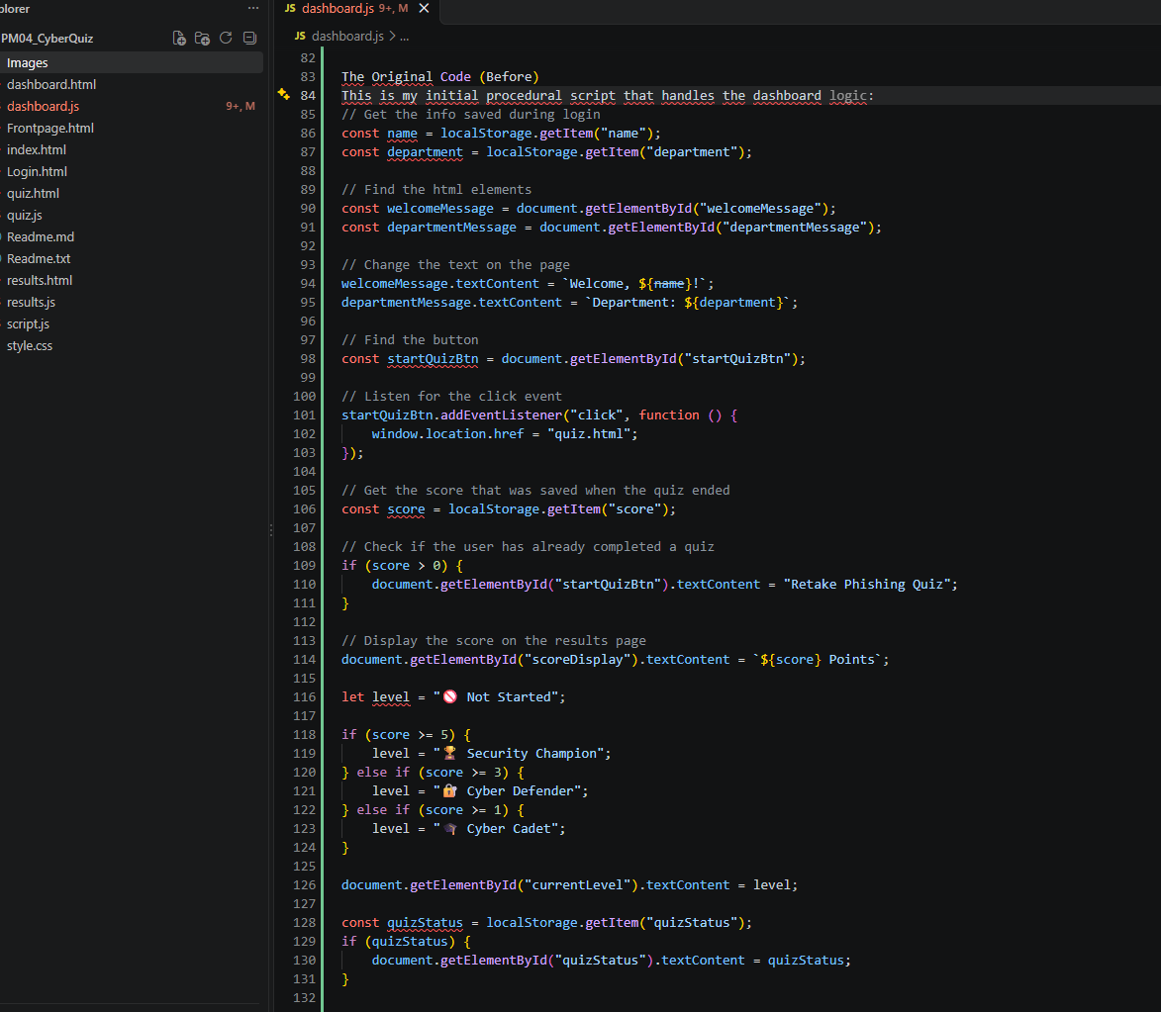

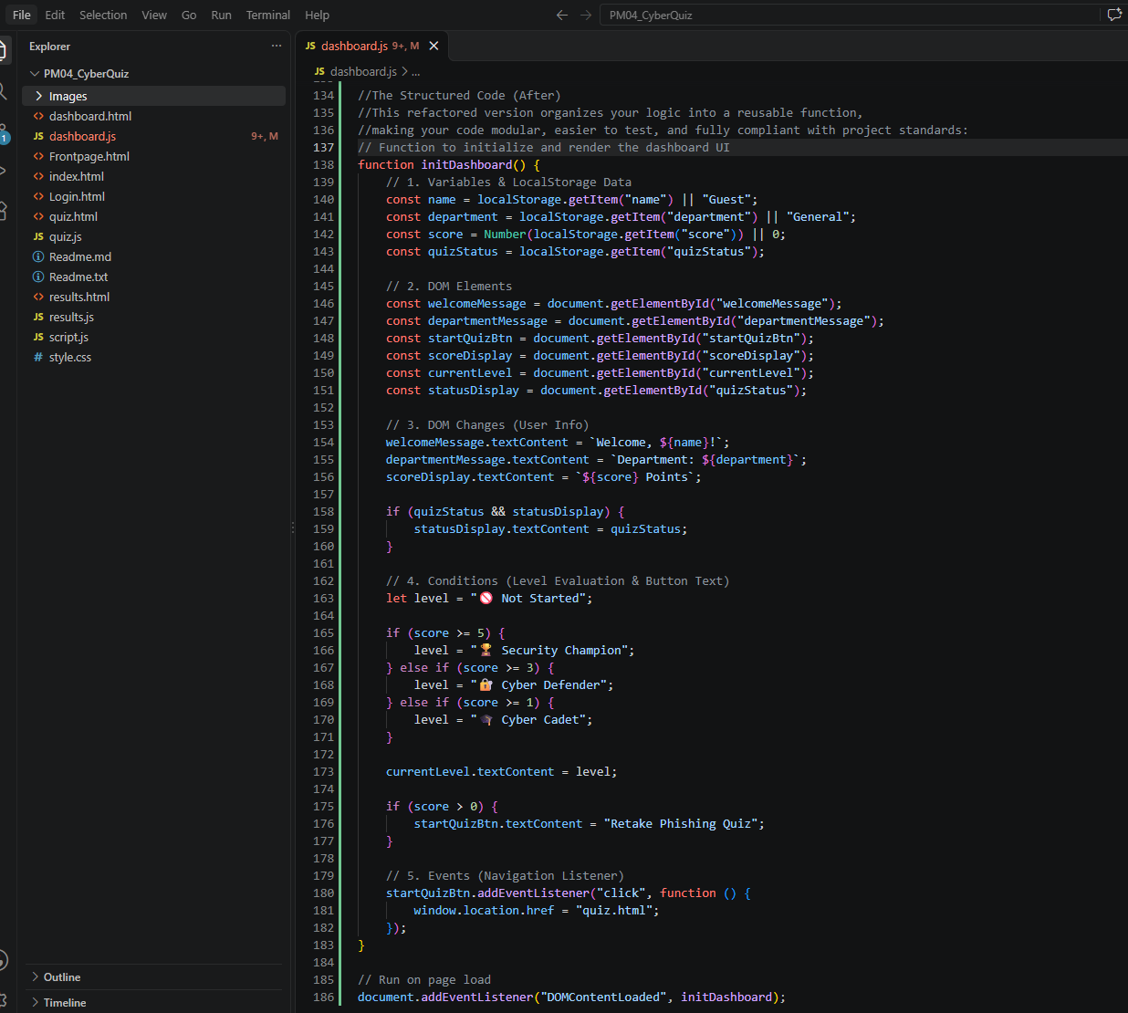

Target User Description: Internal company employees and staff members across various departments who need to complete baseline cybersecurity training and monitor their progress.
2. Functional RequirementsPersonalized Dashboard: The application must retrieve the user's name and department from localStorage and display a personalized welcome message. Quiz Navigation: The interface must include a button that redirects users to the quiz page (quiz.html) when clicked. Dynamic Score Tracking: The app must read the user's past score from localStorage and display their total points. Conditional UI Updates:If a user has completed the quiz before (score > 0), the action button text must dynamically change to "Retake Phishing Quiz". The app must evaluate the score against specific thresholds to assign a security level badge (Security Champion, Cyber Defender, Cyber Cadet, or Not Started). Status Updates: The app must check for and display any saved quizStatus retrieved from localStorage.
3. Wireframe / Page Sketch LayoutHeader Section:[Welcome, [Name]!] (Target element: welcomeMessage) [Department: [Department Name]] (Target element: departmentMessage) Main Status Panel:Current Level Badge: e.g., 🏆 Security Champion (Target element: currentLevel) Score Display: e.g., [X] Points (Target element: scoreDisplay) Quiz Status Message (Target element: quizStatus) Action Area:Interactive Button: [Start Quiz] / [Retake Phishing Quiz] (Target element: startQuizBtn)

Wireframe / Page Sketch
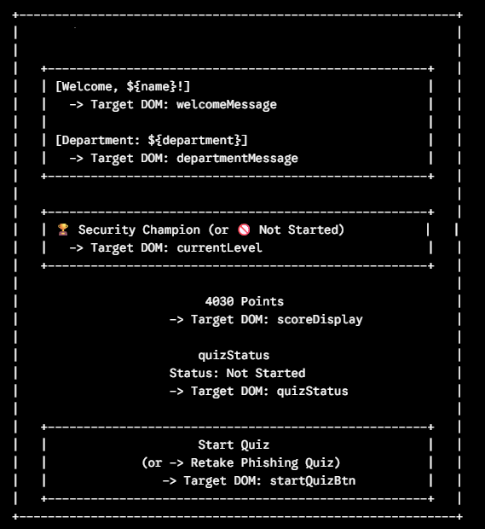

4. Planned Data Structure and LogicBased on your code, here is the breakdown of variables, DOM elements, conditions, and events:Variables & LocalStorage Keys:name, department, score, quizStatus (retrieved via localStorage.getItem()). level (initialized to "🚫 Not Started" and conditionally updated). DOM Elements:welcomeMessage, departmentMessage, startQuizBtn, scoreDisplay, currentLevel, quizStatus (queried via document.getElementById()). Conditions & Logic:Score evaluation logic:score >= 5 $\rightarrow$ Level: "🏆 Security Champion" score >= 3 $\rightarrow$ Level: "🔐 Cyber Defender" score >= 1 $\rightarrow$ Level: "🎓 Cyber Cadet" Default $\rightarrow$ Level: "🚫 Not Started" Retake check: if(score > 0) updates button text content. Events & DOM Changes:click event listener attached to startQuizBtn to change window.location.href to "quiz.html". Dynamic modification of .textContent across multiple dashboard elements.

JavaScript Concepts Breakdown

Variables: name, department, score, level, quizStatus
- DOM Elements: welcomeMessage, departmentMessage, startQuizBtn, scoreDisplay, currentLevel
- Conditions: if/else if/else statements evaluating score thresholds for achievement levels and retake status.
- Events: click event listener on startQuizBtn.
- DOM Changes: Dynamic updates to .textContent and window.location.href navigation.

TEST PLAN:
Test Case ID | Scenario / Input | Expected Result | Pass/Fail Criteria
TC01 | First-time visitor (No score in localStorage) | Button reads "Start Quiz", level shows "Not Started", score displays as points. | Button links to quiz.html successfully.
TC02 | Returning user with score of 3 | Button text updates to "Retake Phishing Quiz", level displays "Cyber Defender", score displays correctly. | UI accurately reflects saved localStorage values.
TC03 | User clicks the action button | Browser redirects to quiz.html. | Navigation triggers instantly on click.

6. GitHub Repository & README Outline
- Repository Name: phishing-mini-quiz-app
- README Outline:
  - Project Overview: A brief description of the phishing mini-quiz workplace application.
  - Features: LocalStorage user persistence, dynamic level grading, and interactive dashboard.
  - Setup Instructions: Steps to clone the repository and run it locally via a live server.
  - Technologies Used: HTML5, CSS3, JavaScript (ES6).
Below is the README Outline.
CyberAware Quiz
## Overview

CyberAware Challenge is a gamified cybersecurity awareness platform designed to improve employee security knowledge through an interactive quiz,
The platform helps teams become more cybersecurity aware, measure employee knowledge, and identify training opportunities.

## Features

- User login
- Cybersecurity quiz
- Real-time scoring
- Gamification and badges
- User dashboards
---
## Categories

- Phishing Awareness
- Password Security
- Social Engineering
- Device Security
- Safe Browsing
- Compliance
---
## User Roles
### Employee
- Take quizzes
- Earn badges
- Track progress
---
## Technology Stack
Html
JS
CSS
---
## Gamification
Users earn points and badges for completing cybersecurity challenges.
Badge Examples:
- Security Champion
- Phishing Hunter
- Password Master
- Data Defender
---
## Future Roadmap

- Teams Integration
- Mobile Support
- AI Generated Questions
- Adaptive Learning
---
## Author

Activity 4.2: Project Build and Version Control
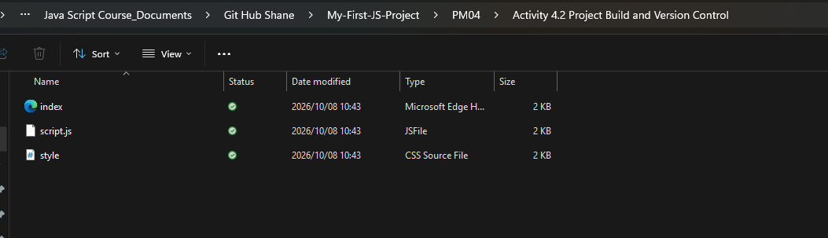

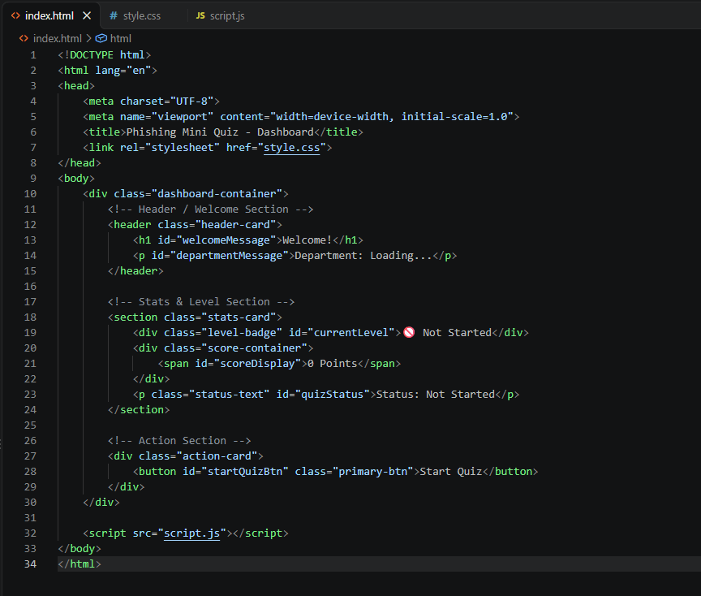

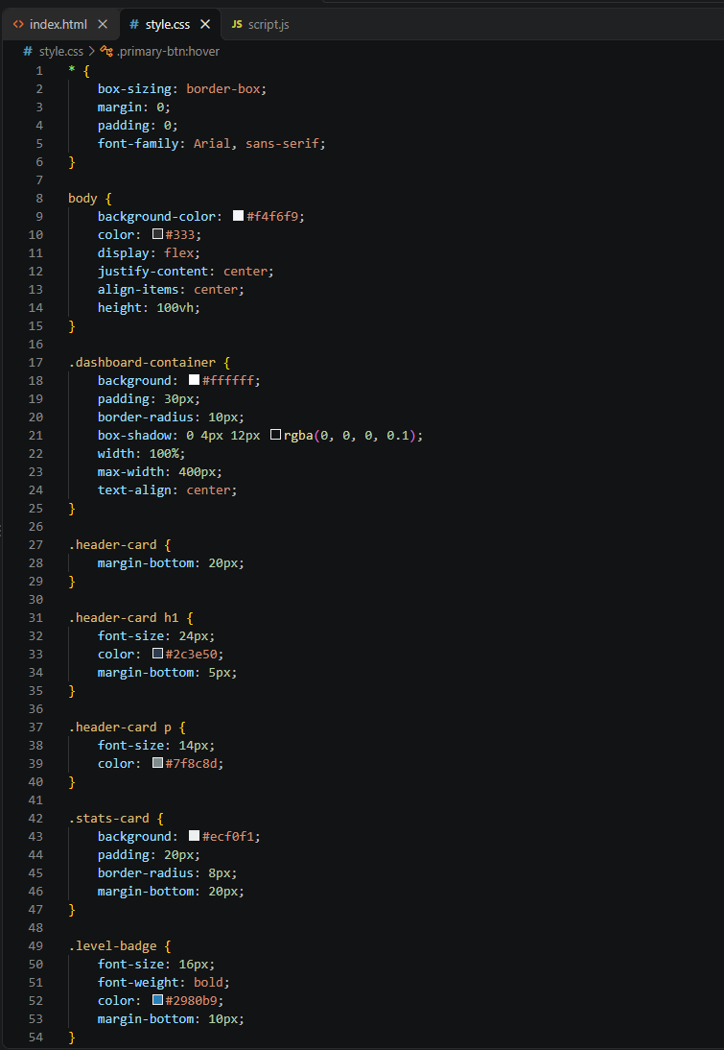
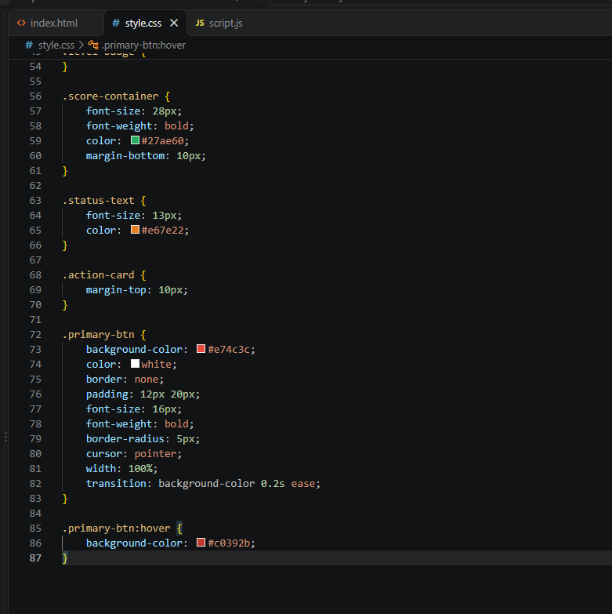

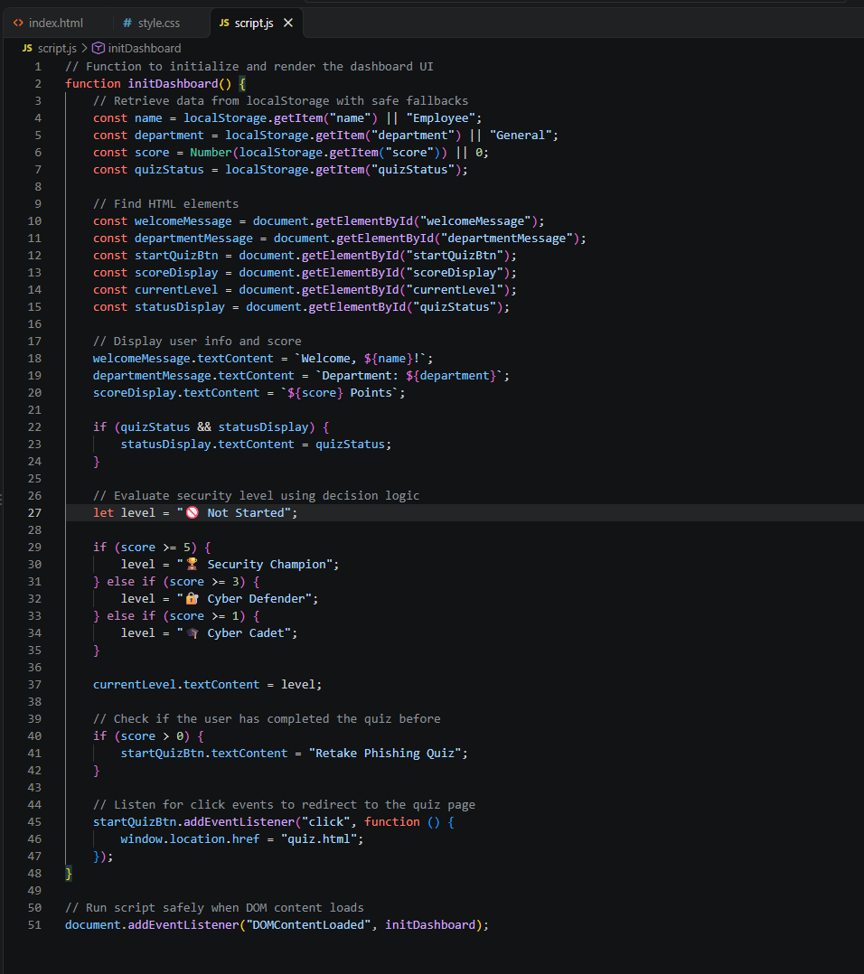

Scenario A: BEFORE (First-Time User / Empty LocalStorage)
When a user visits the dashboard for the very first time before taking the quiz, localStorage is completely empty.
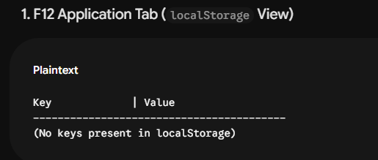

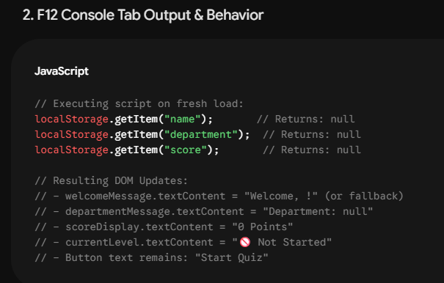

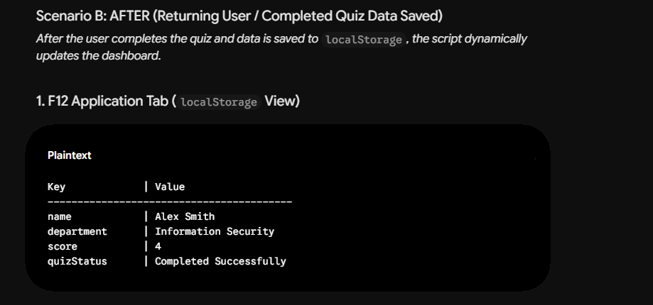

F12 Console Tab Output & Inspection
Verification in browser console, utilising the F12 Console:
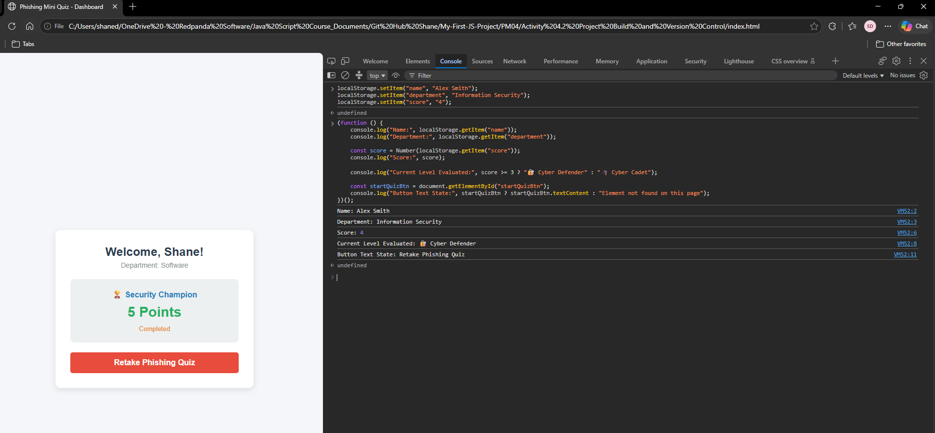

https://github.com/welkinspirit-hash/My-First-JS-Project.git

C:\Users\shaned\OneDrive - Redpanda Software\Java Script Course_Documents\Git Hub Shane\My-First-JS-Project\PM04\Activity 4.2 Project Build and Version Control

2. Version Control Evidence (Git Commit History)
To fulfill the requirement for commit history and meaningful commits:
# 1. Initialize your local Git repository
git init
# 2. Add and commit your HTML and CSS files
git add index.html style.css
git commit -m "feat: setup basic HTML structure and CSS layout"
# 3. Add initial script logic for localStorage retrieval
git add script.js
git commit -m "feat: implement localStorage data retrieval for user name and department"
# 4. Add score tracking and security level grading logic
git add script.js
git commit -m "feat: add score tracking and dynamic security level grading logic"
# 5. Add event listener for redirection and button text updates
git add script.js
git commit -m "feat: add event listener for quiz redirection and dynamic button text updates"
# 6. Refactor code into the DOMContentLoaded initialization function
git add script.js
git commit -m "refactor: wrap dashboard logic in a DOMContentLoaded initialization function"3. Branch / Pull Request Evidence

- Branch Created: feature/dashboard-logic
- Pull Request: Merged feature/dashboard-logic into main after verifying code readability, comments, and test criteria.

Activity 4.3: Project Testing, Debugging and Improvement
Test Case IDFeature / ModuleTest Scenario / InputExpected ResultActual ResultStatusTC-01Login FormEmpty Name & Department inputs submitted
Alert prompt ("Please enter your name and department.") appears, preventing continuation.
Alert prompt displayed, execution halted successfully.PassTC-02Login FormValid Name and Department entered
Data saved to localStorage, navigates to dashboard/starts new quiz.
Values stored properly, transitions to the active quiz screen.PassTC-03Quiz LogicSelecting an incorrect answer
Score does not increment, button marked with "incorrect" class, feedback shows incorrect message, progresses after 1 second.
Visual state updates to incorrect style, advances correctly.PassTC-04Quiz LogicSelecting the correct answer
Score increments, button marked with "correct" class, feedback shows correct message, progresses after 1 second.
Score updates, feedback displays correct, advances correctly.PassTC-05Results & DashboardCompleting all quiz questions
Final score saved to localStorage, quiz status updated to "Completed", redirects to results screen.
Score and completion status successfully logged and displayed.Pass

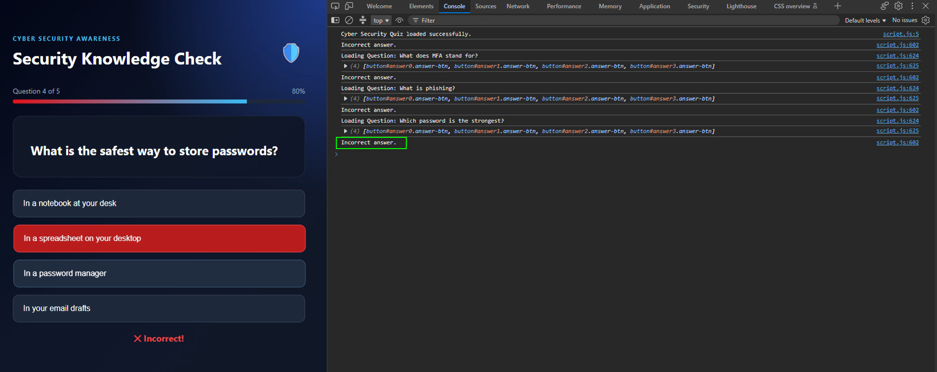

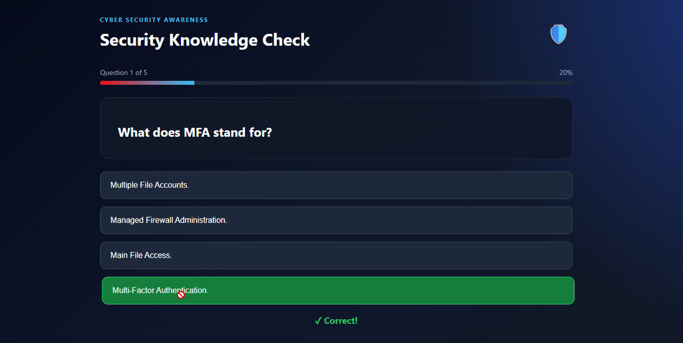

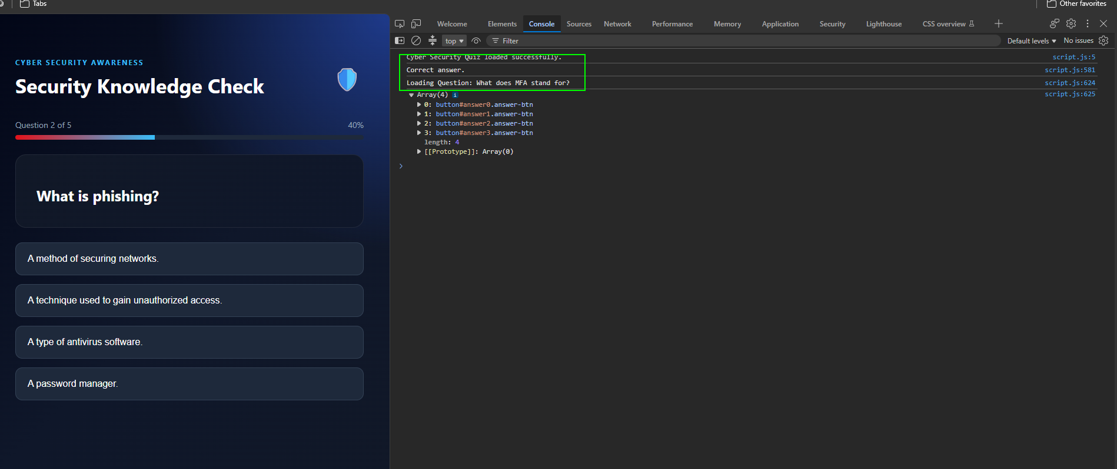
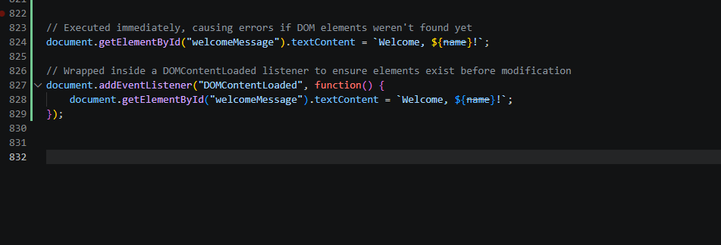

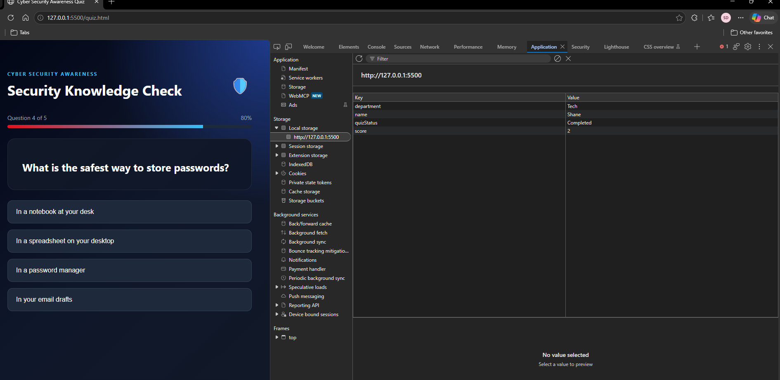

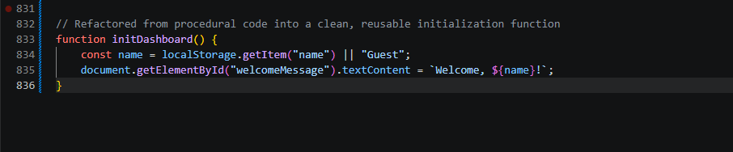
git add .
git commit -m "Refactor dashboard logic into reusable function and add local storage fallbacks"

Activity 4.4: Final Demonstration, Presentation and Reflection

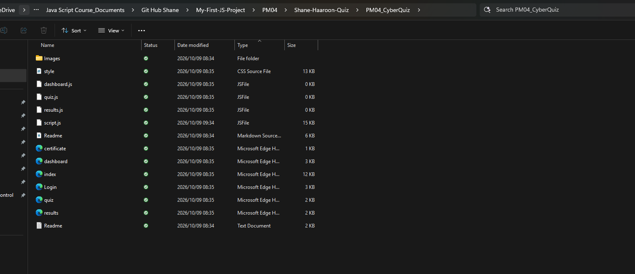
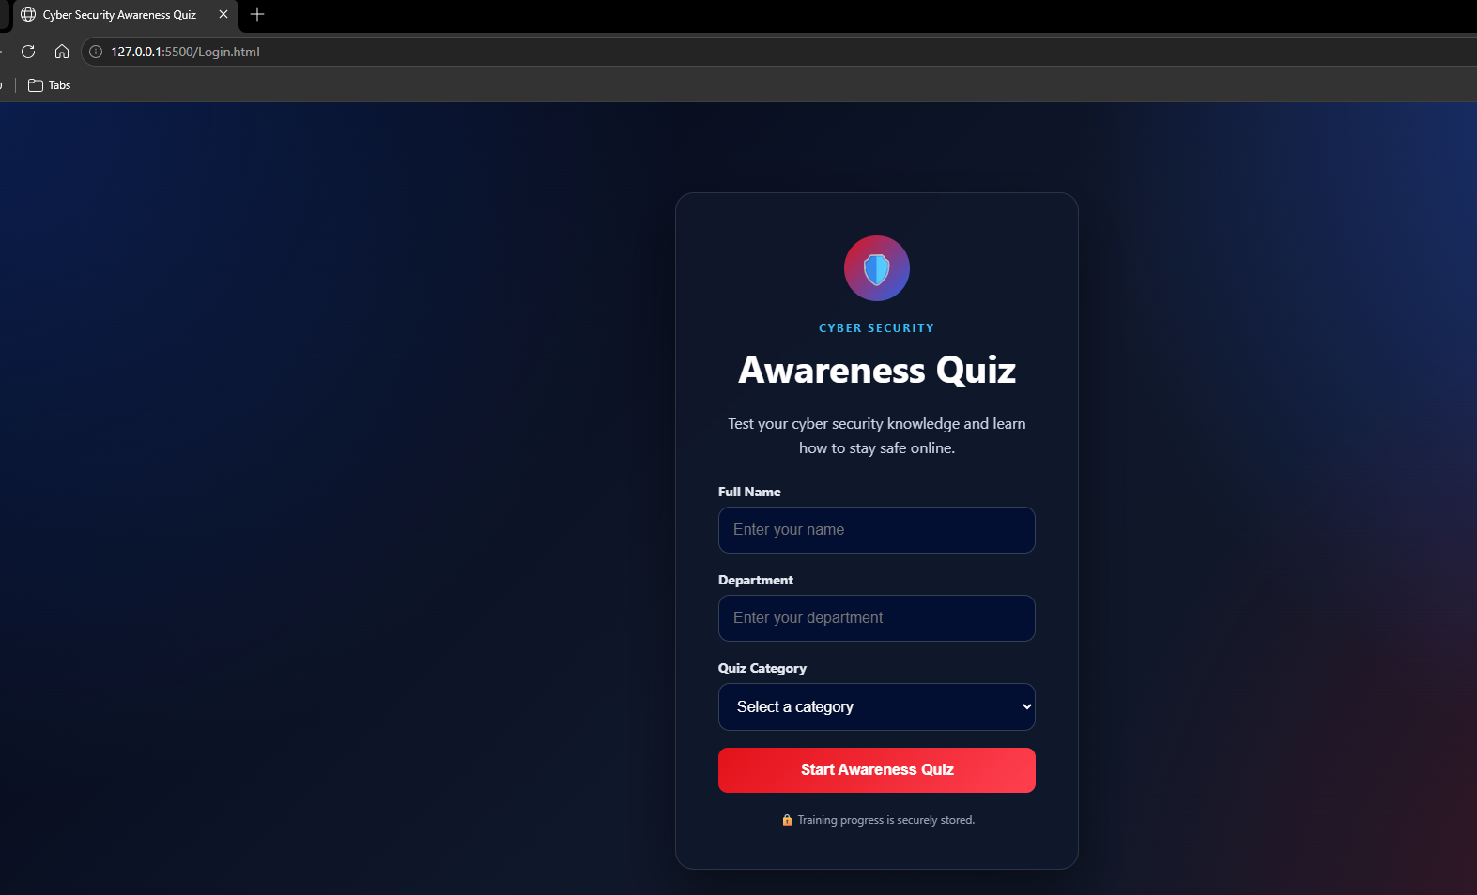

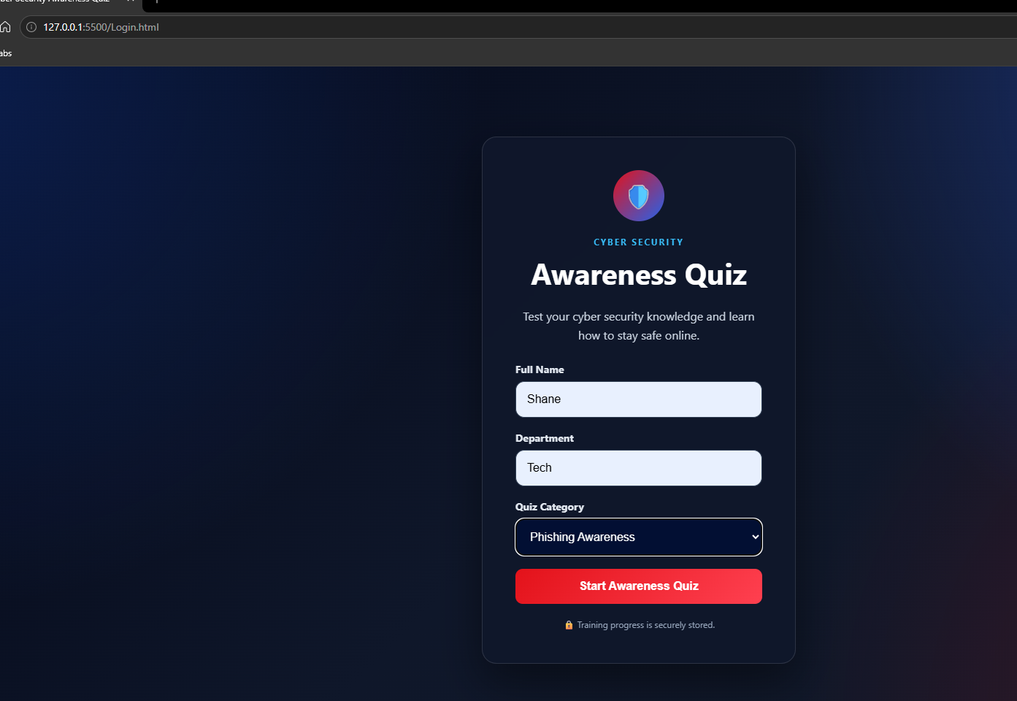

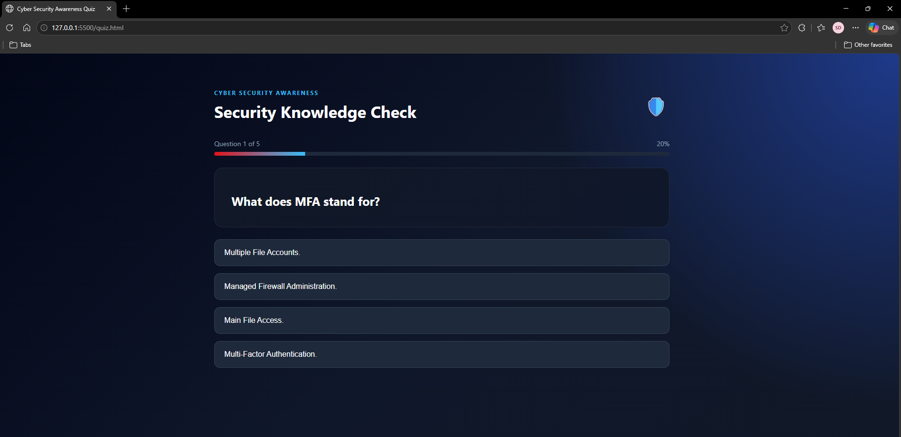

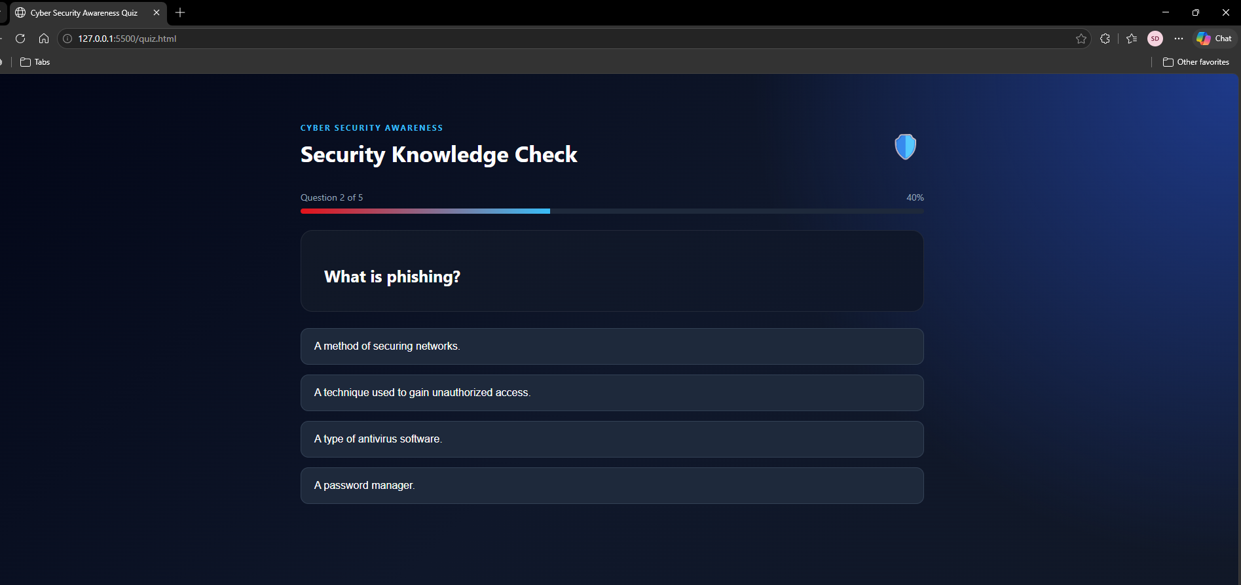

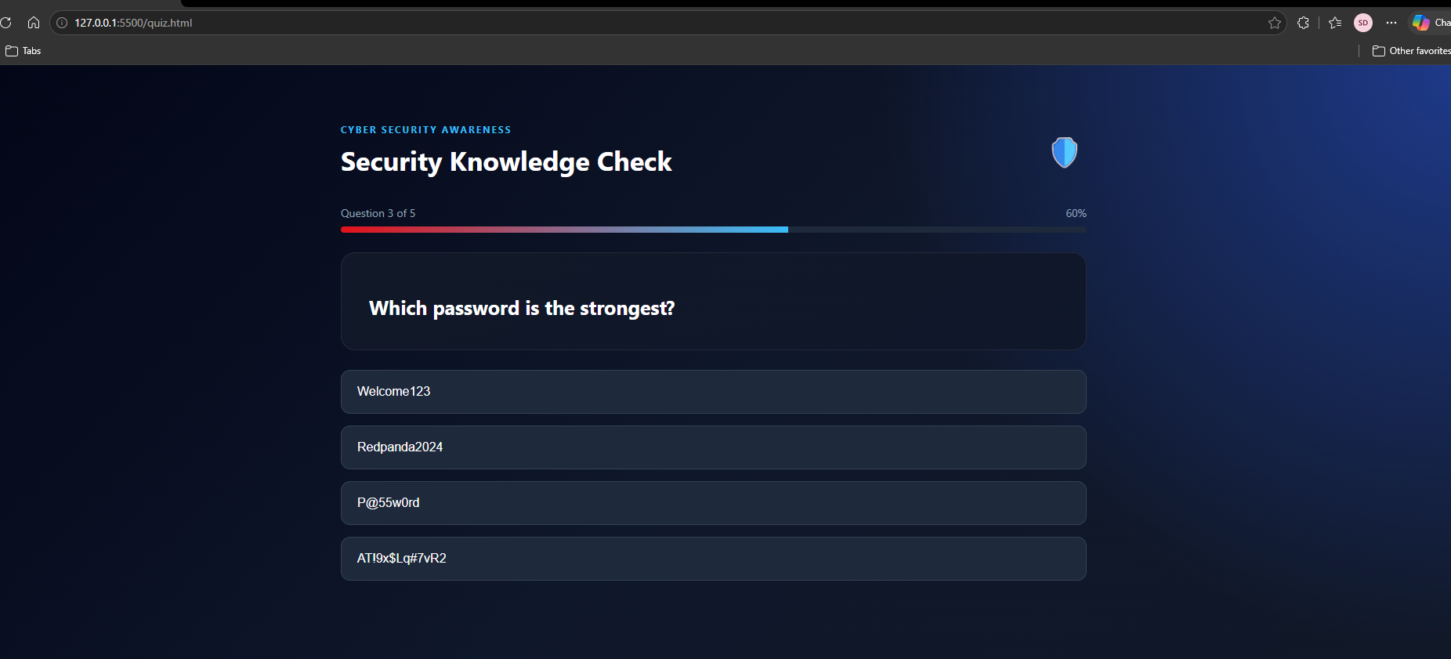

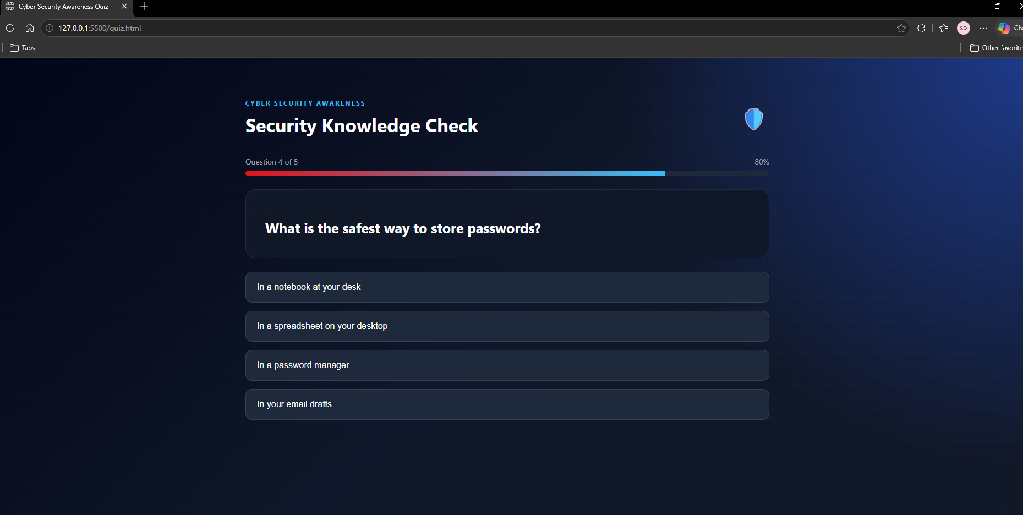

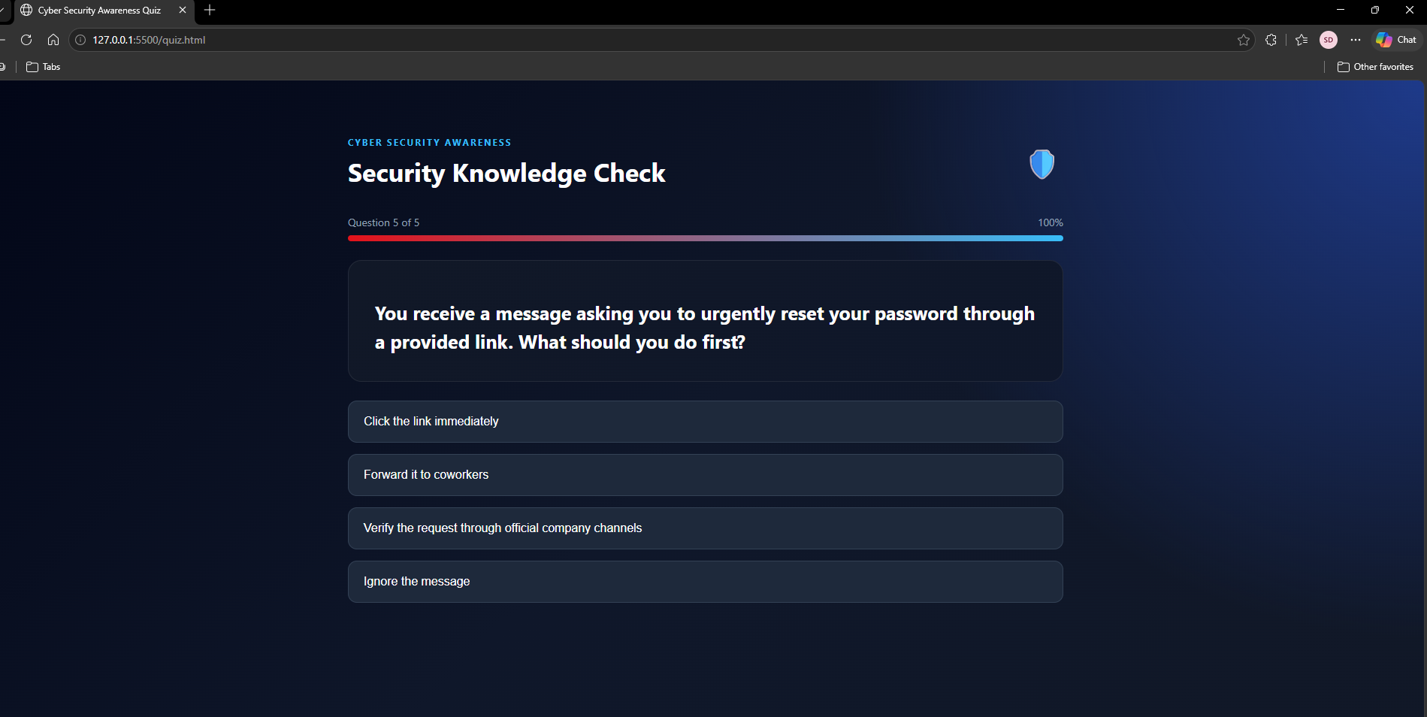

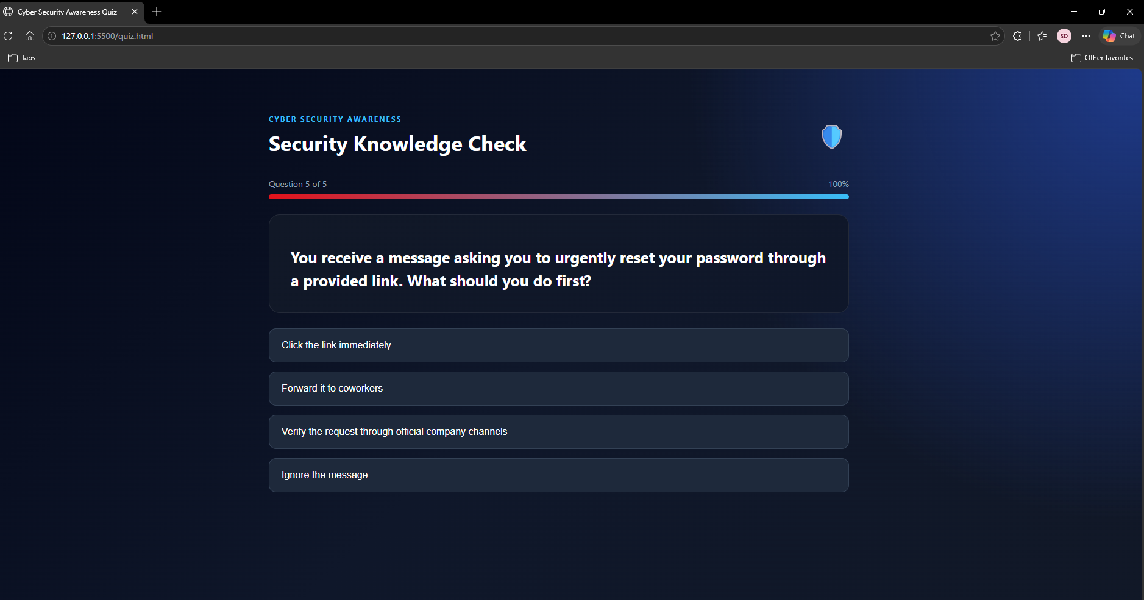

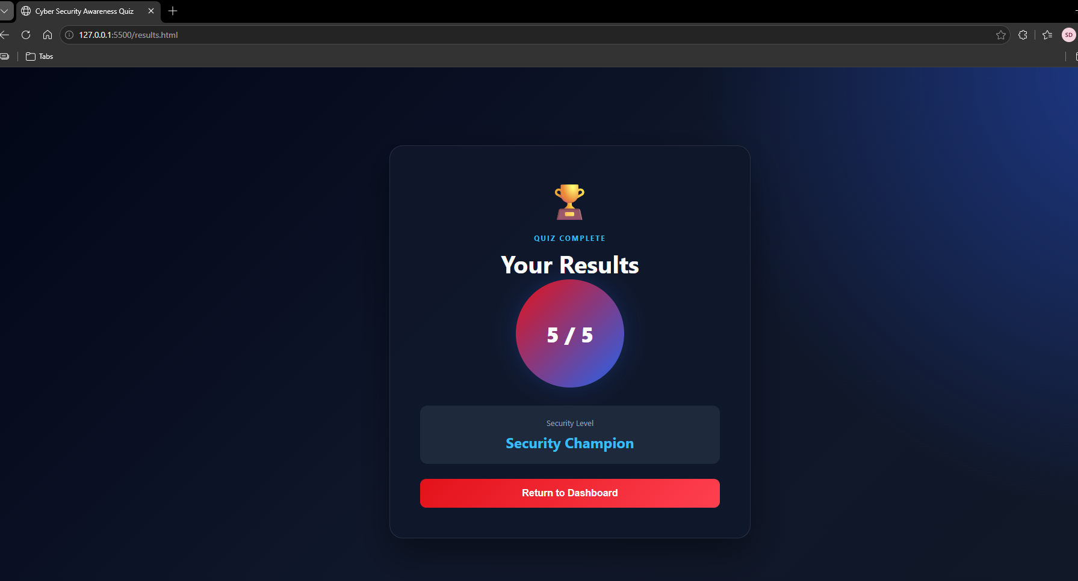

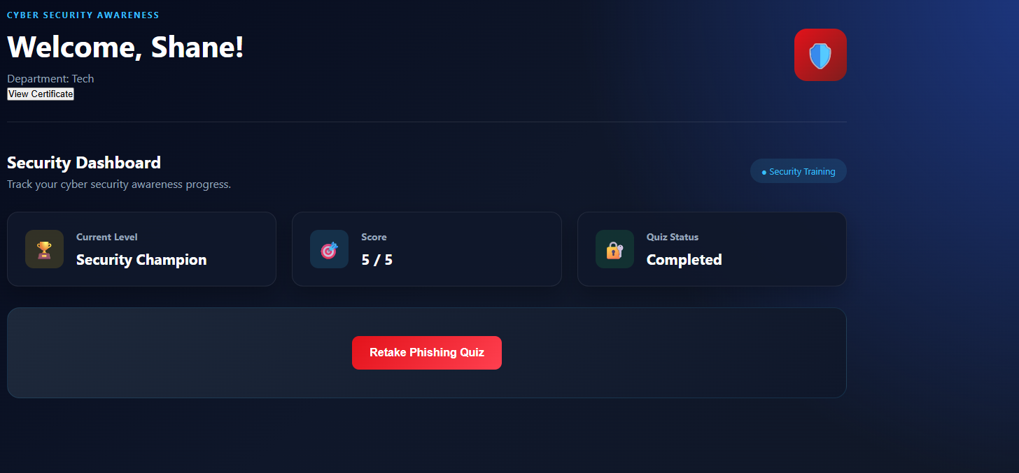
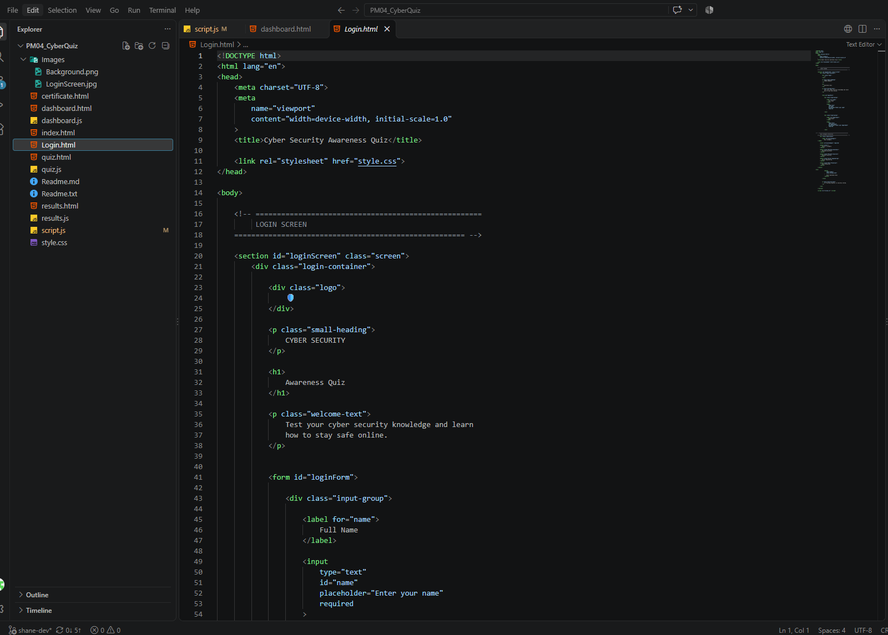
Here is a short breakdown of the instructions from the image:

- Demonstrate the main user flow: Walk through the application sequence—starting from the login screen, viewing the dashboard, completing the quiz questions, and seeing the final results screen.
• Login & Authentication: The user opens the application and is greeted by the login screen, where they must input their name and department before proceeding.
• Dashboard Overview: Upon successful login, user details and previous statistics are loaded into the dashboard, showing their current security level (e.g., Cyber Cadet, Cyber Defender, or Security Champion) and quiz status.
• Interactive Quiz Execution: Clicking the start button launches the quiz interface, where questions are loaded dynamically with a progress bar indicator. The user selects an answer option, receives immediate visual feedback, and advances through the questions.
• Results & Completion: After completing all questions, the final score is calculated, saved to browser storage, and displayed on the results screen with an option to return to the dashboard or retake the quiz.

- Explain HTML, CSS and JavaScript responsibilities: Describe how HTML structures the page elements, CSS styles the visual layout, and JavaScript handles dynamic behavior, user input, and state management.
- HTML provides the foundational skeleton and layout elements that the JavaScript script interacts with:
- • Screen Containers: Defines the distinct views of the application using IDs like loginScreen, dashboardScreen, quizScreen, and resultsScreen.
- • Form Inputs: Structures the login interface (loginForm) with input fields for user identification (name and department).
- • Dynamic Display Elements: Sets up structural placeholders for dynamic text updates, such as welcomeMessage, departmentMessage, scoreDisplay, currentLevel, and quizStatus.
- • Quiz & Progress Elements: Houses the question text container (question), progress indicators (questionNumber, progressPercent, progressFill), feedback text (feedback), and the four individual answer buttons (answer0 through answer3).

CSS Responsibilities (Presentation & Styling)
CSS controls how the user interface looks and responds visually during user interaction:
- Layout and Theming: Styles the dark-mode theme, structural spacing, typography, and modern card-based layout seen across all screens.
- Screen Visibility Management: Works directly with JavaScript's showScreen() function by utilizing a .hidden utility class to toggle which screen container is visible to the user at any given time.
- Interactive State Styling: Provides visual feedback rules through utility classes like .correct (highlighting correct answers, typically in green) and .incorrect (highlighting wrong choices, typically in red) when managed by checkAnswer().

JavaScript Responsibilities (Behavior & Logic)
JavaScript powers all the dynamic interactivity, data storage, and state management of your application:
- DOM Selection & Manipulation: Caches DOM elements using document.getElementById() and dynamically updates their content (e.g., injecting question text, calculating progress percentages, and updating welcomeMessage.textContent).
- View Switching & Event Handling: Listens for user actions using .addEventListener()—such as form submissions on login, button clicks to start/retake the quiz, and user selections on answer choices—to trigger functions like startNewQuiz() and checkAnswer().
- State & Data Persistence: Manages user progress and details across sessions using the browser's localStorage API to save, update, and retrieve keys like name, department, score, and quizStatus.
- Quiz Engine & Flow Control: Iterates through the quizData array, tracks currentQuestionIndex, evaluates user selections against the correct index, updates scores, and handles asynchronous delays using setTimeout() before transitioning to the next question or the results screen.

- Explain at least three JavaScript concepts used: Detail core concepts applied in your code, such as DOM manipulation, event listeners, and local storage data persistence.

DOM Manipulation
- Explanation: This concept allows JavaScript to interact with the webpage by selecting HTML elements and dynamically changing their content, styles, or classes without needing to reload the page.
Event Listeners
- Explanation: Event listeners watch for user interactions—such as a button click or a form submission—and trigger specific functions when those actions occur.
Data Persistence (localStorage)
- Explanation: This allows the browser to save data locally across different pages and sessions, ensuring that user details or quiz scores aren't lost when transitioning views.

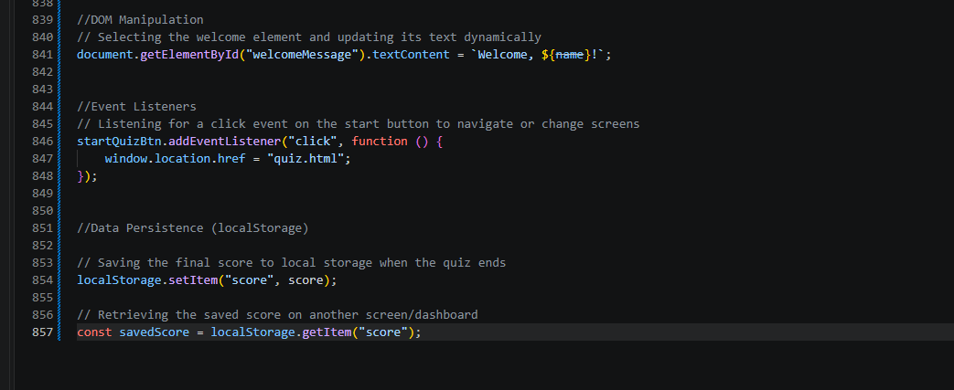

Challenge, Limitation, and Future Improvement
- Challenge: Managing asynchronous state and timeout delays so that answer buttons could not be clicked multiple times before loading the next question. This was resolved by immediately disabling answer choices upon selection.
- Limitation: The application currently relies entirely on browser localStorage to track scores and user state, meaning data is tied to a single browser session and device without a secure backend database.
- Future Improvement: Implement a backend server and database (such as Node.js with MongoDB or SQL) to store user authentication, department metrics, and quiz scores securely across multiple devices.
- Final Reflection :
- Developing the Cyber Security Awareness Quiz provided a hands-on opportunity to apply core JavaScript fundamentals—including DOM manipulation, event listeners, and local storage data persistence. Through systematic testing and debugging with browser developer tools, I learned how to identify, isolate, and fix runtime logic issues efficiently. This project highlighted the importance of robust error handling and structured code organization, skills that are directly applicable to building reliable web applications in a professional environment.

